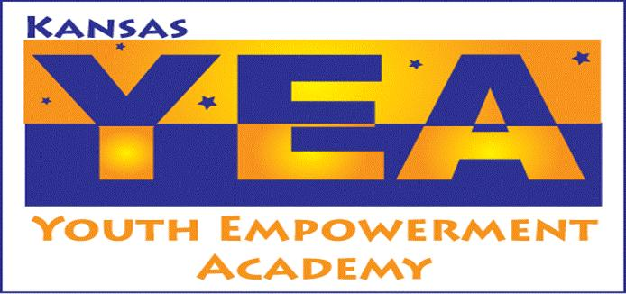
“To educate, mentor and support youth with disabilities to be contributing members of their community.”

DEVELOPMENT COORDINATOR POSITION DESCRIPTION

JOB TITLE | DEPARTMENT | HIRING MANAGER
Development Coordinator |  | Executive Director
POSITION | HOURS PER WEEK | START DATE
Part-Time Equivalency | 20 hours
EMPLOYEE’S NAME | SSN | BASE PAY OR HOURLY WAGE

WORKDAYS
[X] Monday | [X] Tuesday | [X] Wednesday |  | [X] Thursday | [X] Friday |  | [ ] Saturday | [ ] Sunday

MANAGEMENT RESPONSIBILITIES
[ ] None | [ ] 1-5 People | [ ] 6-10 |  | [ ] 11-15 | [ ] 16-25 |  | [ ] 26-50 | [ ] Over 50

FUNCTION
The position works closely with the Executive Director, staff, and community volunteers to plan and implement a comprehensive, integrated development and marketing program based on community alliances and relationship building; to plan and implement the organization's role and profile in the community and to be a primary organizational contact that develops and cultivates individual relationships. This individual will direct his/her work complementary to the spirit and intent of the independent living philosophy.

RESPONSIBILITIES
1. Plan and implement a comprehensive and integrated development program.
A. Plan annual goals and objectives for development.
B. Organize implementation of development activities.
C. Develop communication linkages for meeting goals and objectives.

2. Plan, implement, and develop community support for annual appeals.
A. Organize annual appeal campaigns.
B. Develop and supervise organization and community involvement in annual appeal.
C. Plan public relations, use of media, and marketing materials.

3. Assist in planning and implementing special events.
A. Organize appropriate special events to educate the public about KYEA.
B. Organize volunteer support to develop appropriate fundraising/social activities.
C. Organize staff and volunteers involved with special events.

4. Organize and implement a Planned Giving Program applying known and appropriate models.
A. Develop a written plan to implement program.
B. Organize volunteer support to assist with the program.
C. Develop and recommend policies and guidelines for accepting and managing gifts.

5. Maintain an accurate records processing system.
A. Develop infrastructure to implement and maintain a gift processing system.
B. Maintain accurate and confidential records of gifts given, volunteers and consumers.
C. Assure restricted funds are used as directed.

6. Maintain positive interactions with staff, consumers, and community.

7. Provide input and assistance with all KYEA programs.

8. Other duties as assigned.

EDUCATION REQUIREMENTS
[ ] High School | [ ] Vocational Training |  | [ x ] Undergraduate Degree |  | [ ] Masters Degree
- Minimum two years professional experience in fundraising, marketing, and/or social services with demonstrated success.

- Ability to perform several tasks concurrently, time management and organizational skills.
- Ability to effectively communicate one-on-one, group settings and public presentations.

- Ability to manage, network, train and motivate staff and volunteers.

- Demonstrated excellent written, oral, and interpersonal communication skills.

- Demonstrated ability to work both independently, as part of a team, and to accept direction.

TECHNICAL SKILL REQUIREMENTS
- 2 years of experience using Microsoft – Word, Excel and Access applications
- 2 years of experience working with people with disabilities
- Must have excellent organizational skills and ability to meet all deadlines

PREFERRED QUALITIES
- Baccalaureate degree in related field.

- Demonstrated knowledge of independent living philosophy.

- Experience working with youth and diverse populations.

- Knowledge of writing for development, promotional writing, and journalistic writing.

- Knowledge of data management and word processing.

Employee Signature |  | Date
Employer Signature |  | Date

